Name: Sapargali Temirlan
Group: SE-2403
Instructor: Kozhakhmet Zhaksylyk
PART 1 TASK 1
Deriverables
All deliverables such as foundry project is inside same directory as this document.
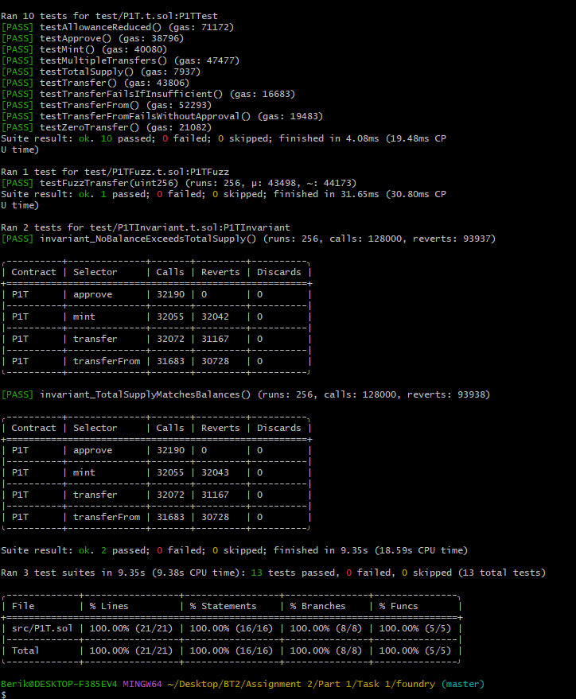
Fuzz testing: Testing a class/function with random or malformed input data.
Unit testing: Testing a class/function with deterministic user created input data and validating it using assertions.

